Control Engineering

Handout – Online Laboratory 7

Name: *Colda Andreea Ariana*

Group: *30332*

For the process described by



1. Design a PI controller that ensures a phase margin .

*Add the obtained PI controller here.*

*30.24 s + 1.081*

*Hc = ---------------*

*27.97 s*

*Use the Bode diagram to prove that the phase margin specification is met.*

*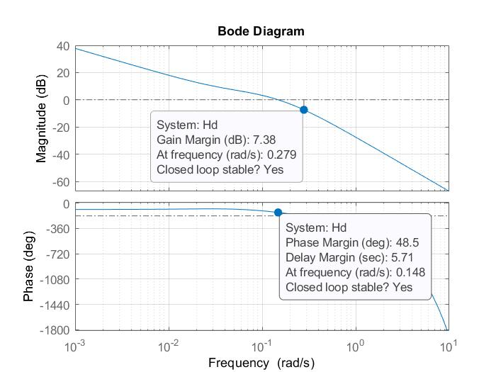*

1. Design a PD controller (choose ) that ensures a phase margin .

*Add the obtained PD controller here.*

*9.913 s + 1*

*Hc = ------------*

*0.9913 s + 1*

*Use the Bode diagram to prove that the phase margin specification is met.*

*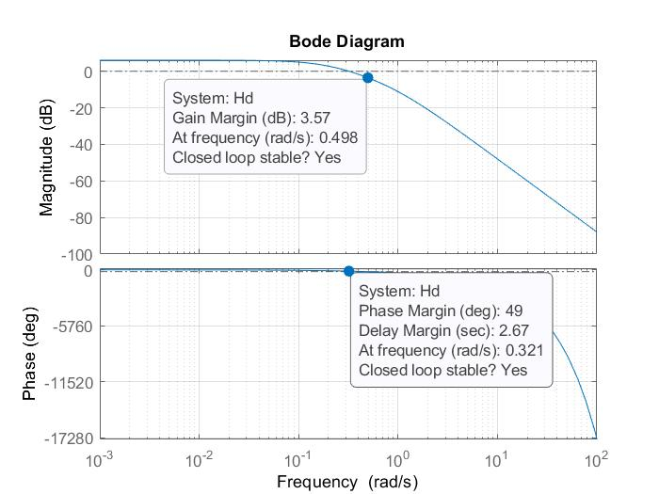*

1. Analyse the performance obtained with both controllers and compare the results.

*Plot the step response of the closed loop system with both controllers (on the same plot).*

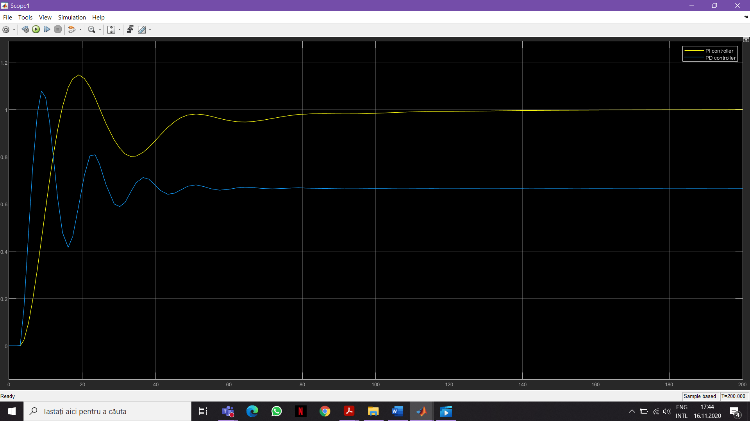

*Briefly comment the obtained performance.*

*The yellow one represents the PI controller and the blue one the PD controller.*

*We can see that the steady state error for the PI is equal to 0, but the PD does not achieve steady state error equal to 0, actually it is around 0.66.*

*The settling time cam be estimated from the graph, so for the PI is around 85 sec and for the PD is 47 sec.*

*We compute the overshoot for both PI an PD controller and for*

* *The PD is sigma1 = ((1.06- 0.66)/0.66)\*100 = 60.6061 %*
* *The PI is sigma2 = (1.15-1)\*100 = 15 %*

*We can see that the overshoot of PD controller is much larger than the overshoot of PI controller.*